*HND Computing - Computer Programming 2 - Assignment 2*

Max Rochefort-Shugar

2019

Table of Contents

Introduction 3

1. Easy Tasks: 3

1.1 - Select and then mark an ISA product as being a closed issue. 3

1.2 - Allow the manager to list all customers in order of their remaining tax year allowance. 3

1.3 - Allow the manager to change the interest rate that is to be paid on a selected ISA product. 4

1.4 - Functionality to add a new ISA product to the bank’s portfolio. 5

1.5 - Functionality to allow the manager to close an ISA owned by one of its customers. 5

1.6 - Functionality to allow the manager to transfer a chosen sum of money between any two ISAs that are owned by the customer, but again subject to the rules that are listed above. 6

2. Hard Tasks: 6

2.1 - Show all customers and allow one to be selected. Then show all the accounts owned by this customer and allow one to be selected. Finally show the current balance of this selected account. 6

2.2 - Allow the manager to perform the end of tax year updates to the database, using the rules listed above. E.g. all account balances should be updated; customer’s tax year deposit allowances reset. 7

2.3 - Functionality to show all transactions, in date order for a selected customer. 7

2.4 - Functionality to provide a summary of the total amount currently invested in each ISA product. 8

2.5 - Functionality to allow the manager to open a new ISA for one of its customers, subject to the rules that are listed. 8

2.6 - Functionality to list the bank’s ISA products in order of those receiving the most deposits over a selected time frame (e.g. since last month, since last year, over the last 5 years). 9

2.7 - The same as above but listing ISA products in order of those having suffered the most withdrawals. 11

# Introduction

In this document I will be providing screenshots and code snippets of my work which prove my completion of this coursework’s tasks. The source code for this project has been fully commented. I have completed all easy and hard tasks.

# 1. Easy Tasks:

## 1.1 - Select and then mark an ISA product as being a closed issue.

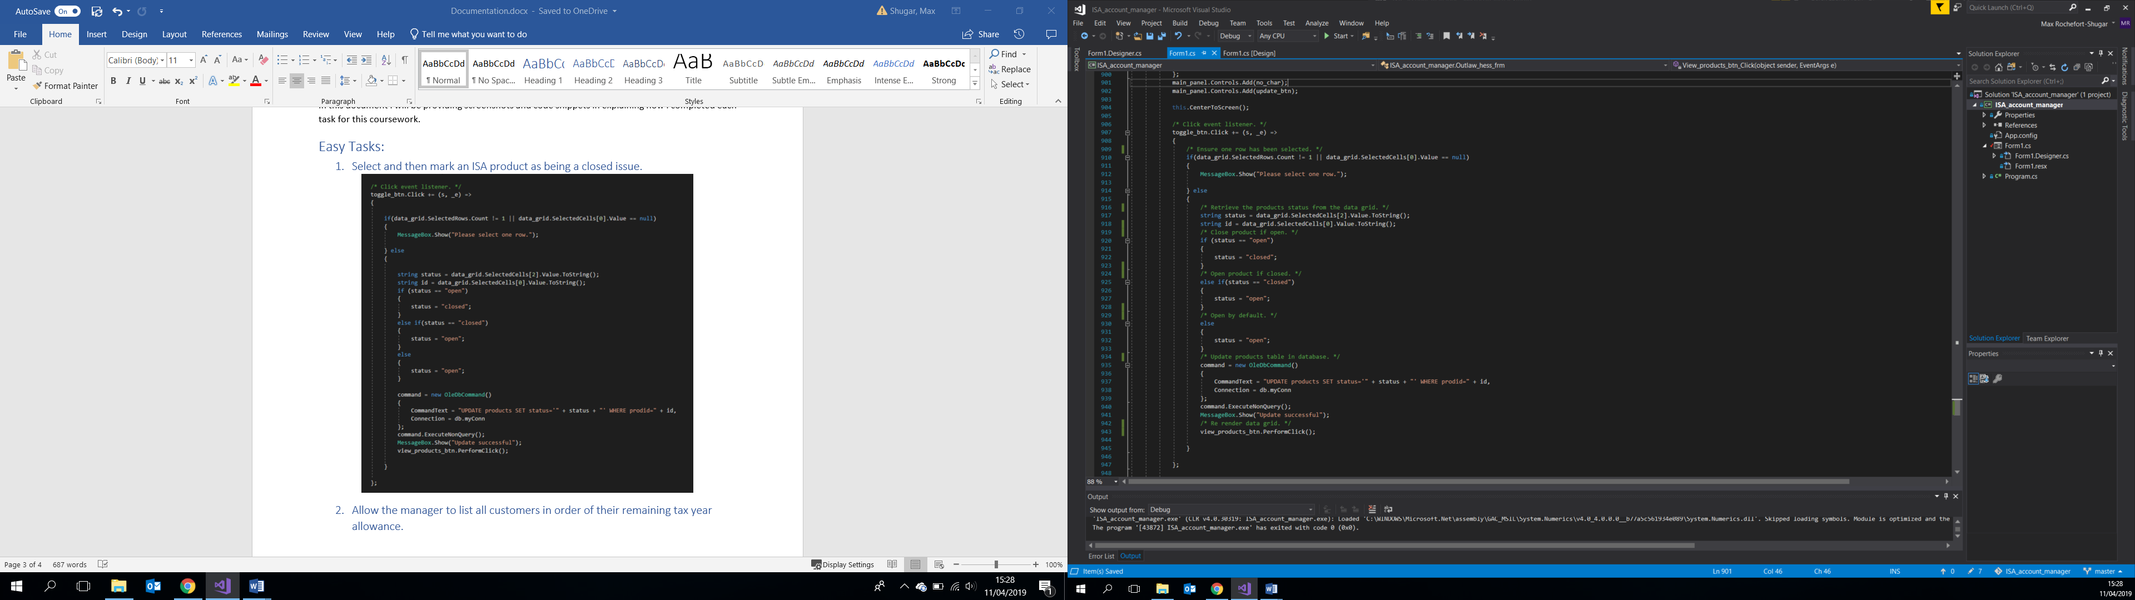

## 1.2 - Allow the manager to list all customers in order of their remaining tax year allowance.

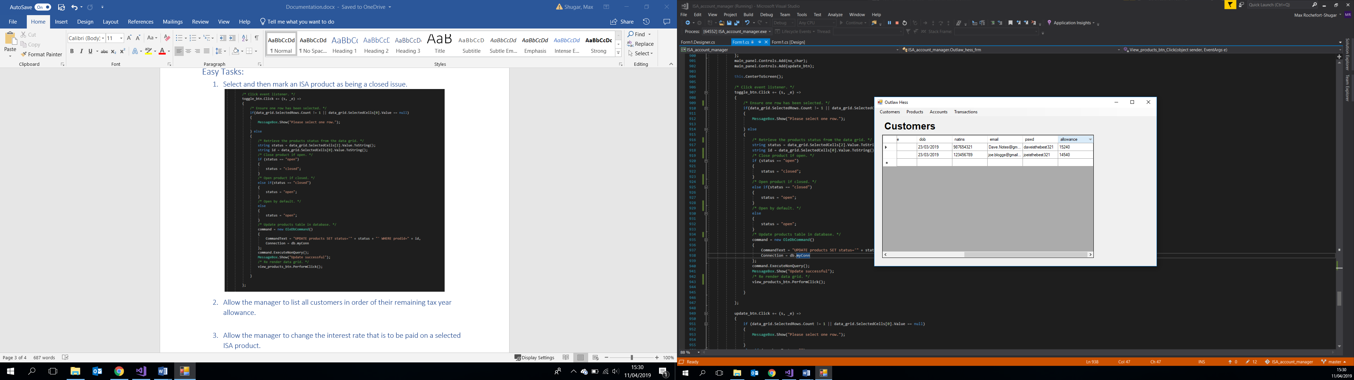

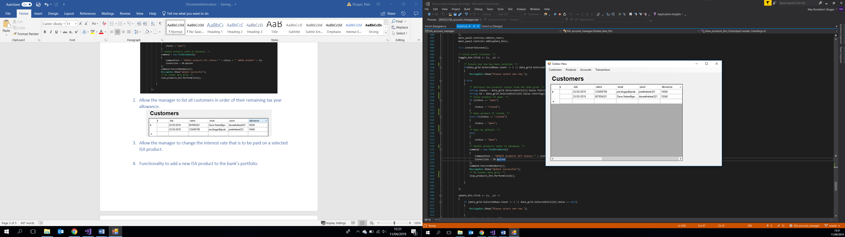

DataGrid view has functionality to order columns in ascending or descending order alphabetically. No need to perform an SQL ORDER BY query.

## 1.3 - Allow the manager to change the interest rate that is to be paid on a selected ISA product.

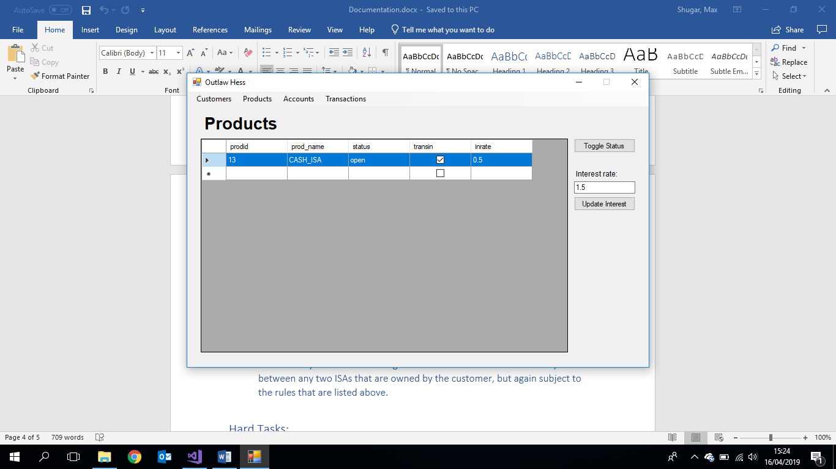

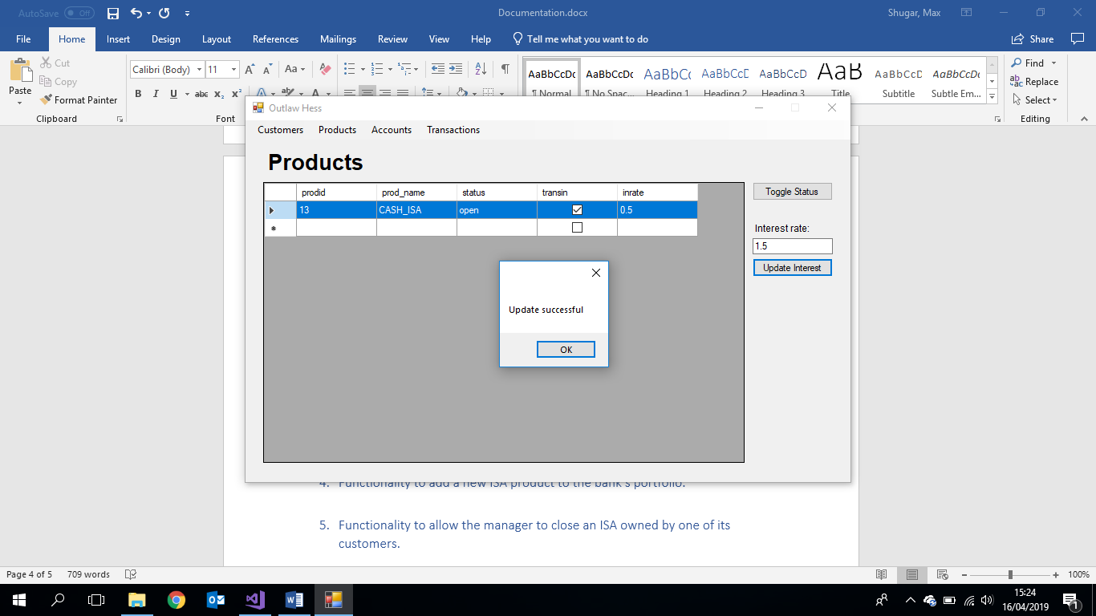

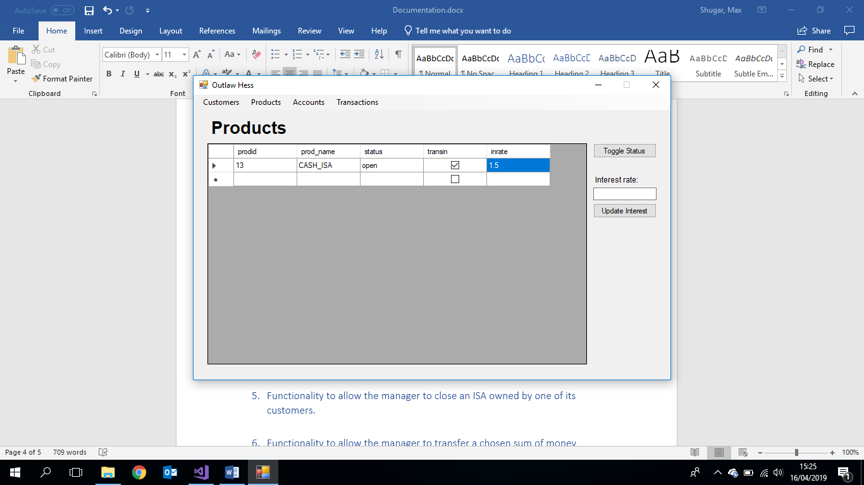

## 1.4 - Functionality to add a new ISA product to the bank’s portfolio.

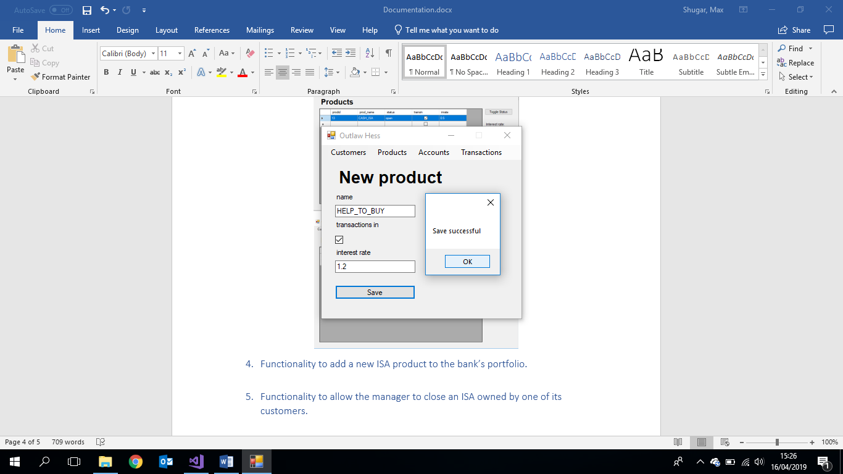

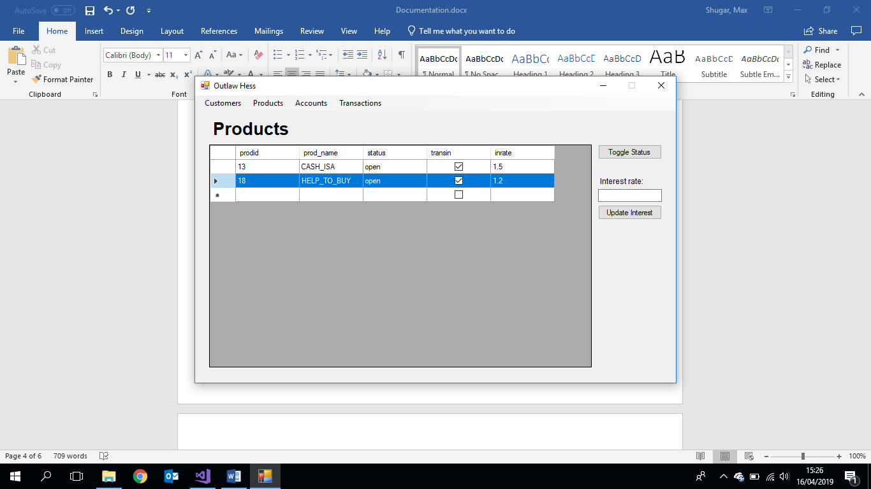

## 1.5 - Functionality to allow the manager to close an ISA owned by one of its customers.

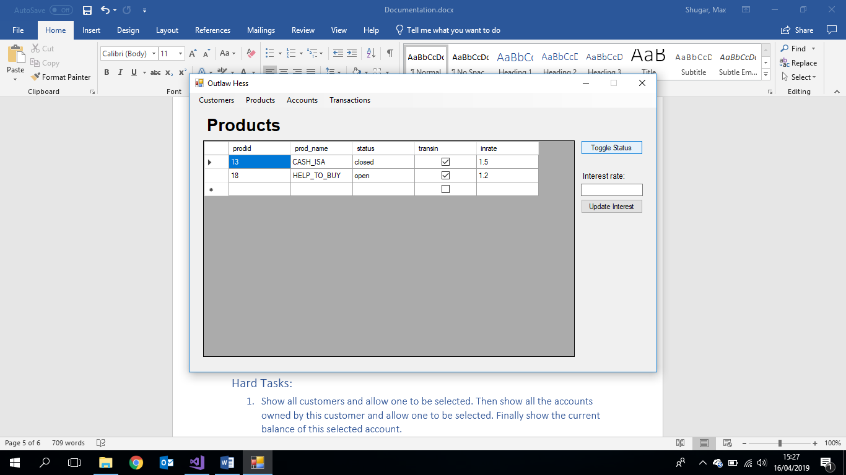

Selecting a row in the products table and clicking the status button toggles the status field column between open and closed.

## 1.6 - Functionality to allow the manager to transfer a chosen sum of money between any two ISAs that are owned by the customer, but again subject to the rules that are listed above.

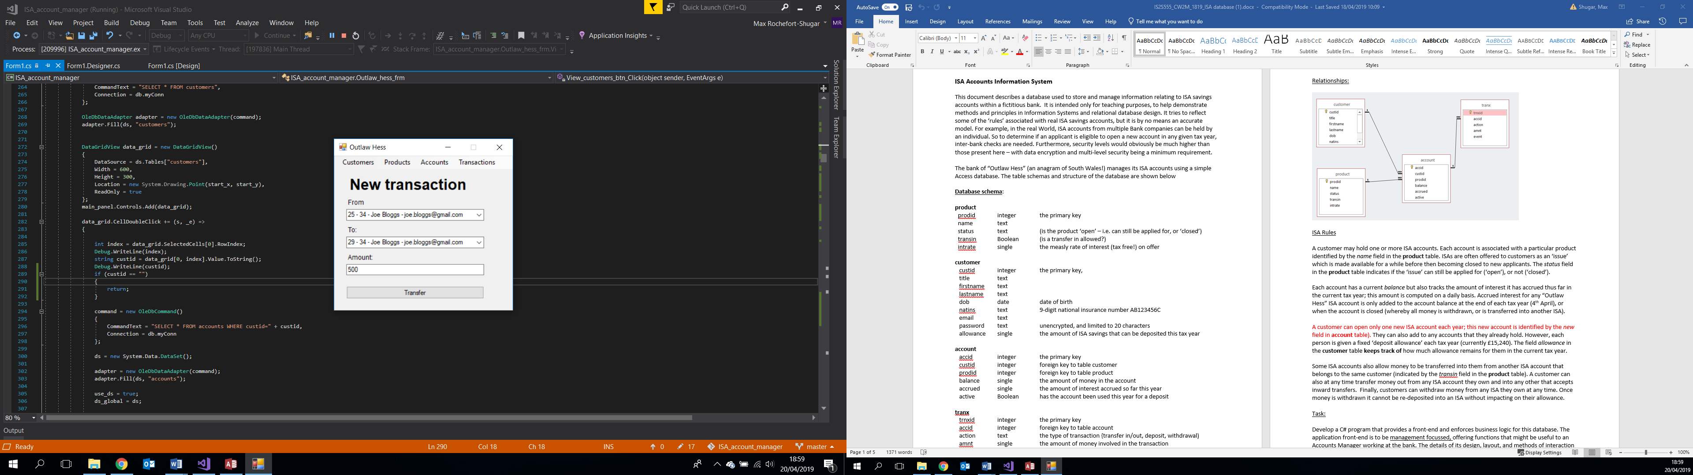

# 2. Hard Tasks:

## 2.1 - Show all customers and allow one to be selected. Then show all the accounts owned by this customer and allow one to be selected. Finally show the current balance of this selected account.

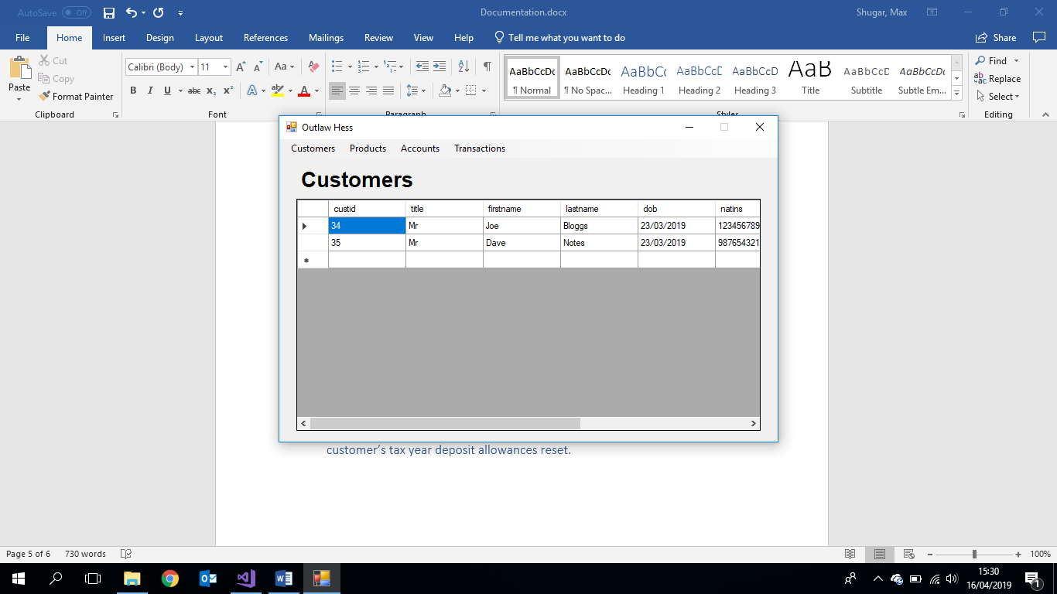

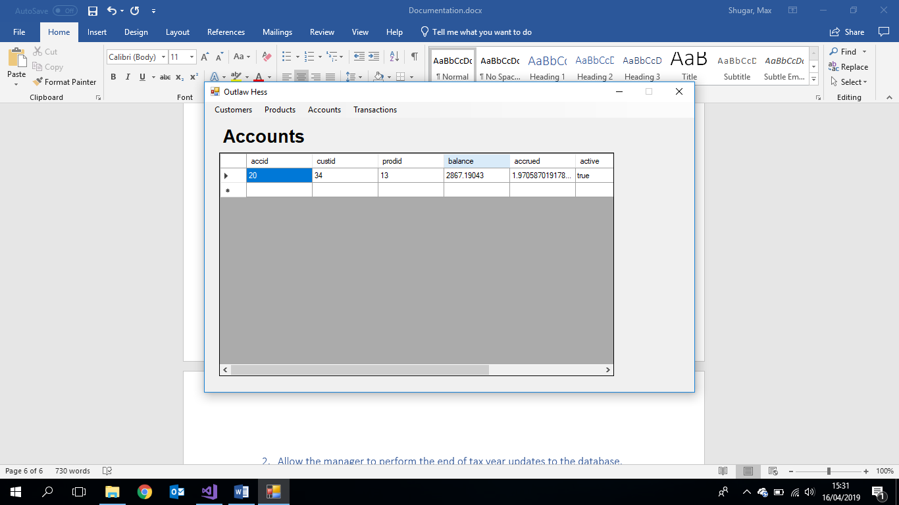

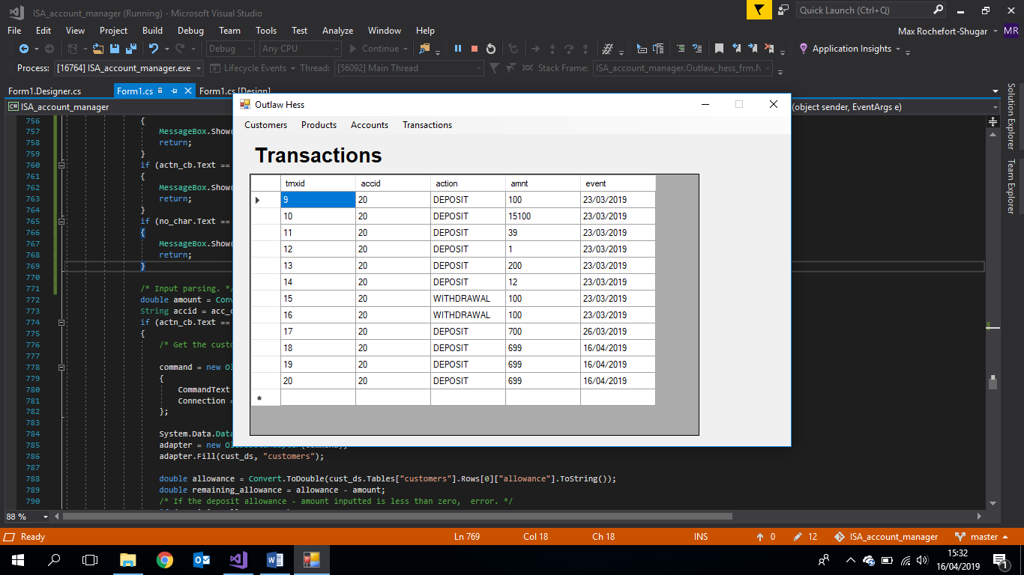

## 2.2 - Allow the manager to perform the end of tax year updates to the database, using the rules listed above. E.g. all account balances should be updated; customer’s tax year deposit allowances reset.

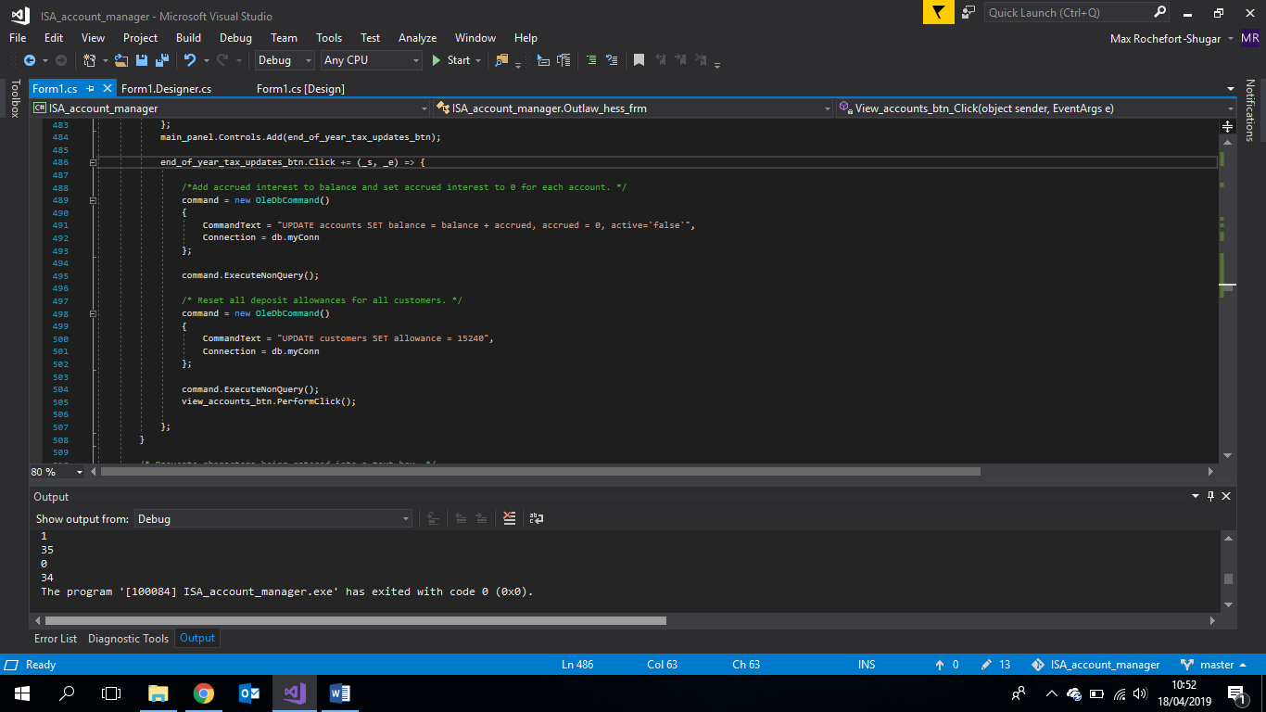

## 2.3 - Functionality to show all transactions, in date order for a selected customer.

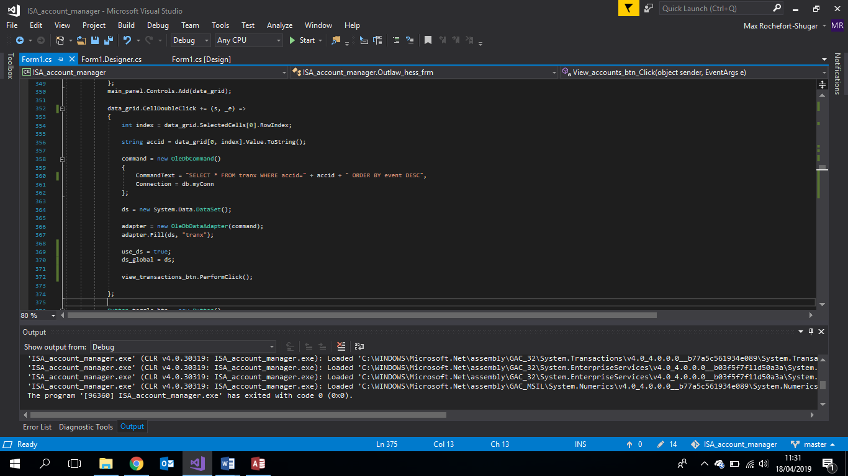

## 2.4 - Functionality to provide a summary of the total amount currently invested in each ISA product.

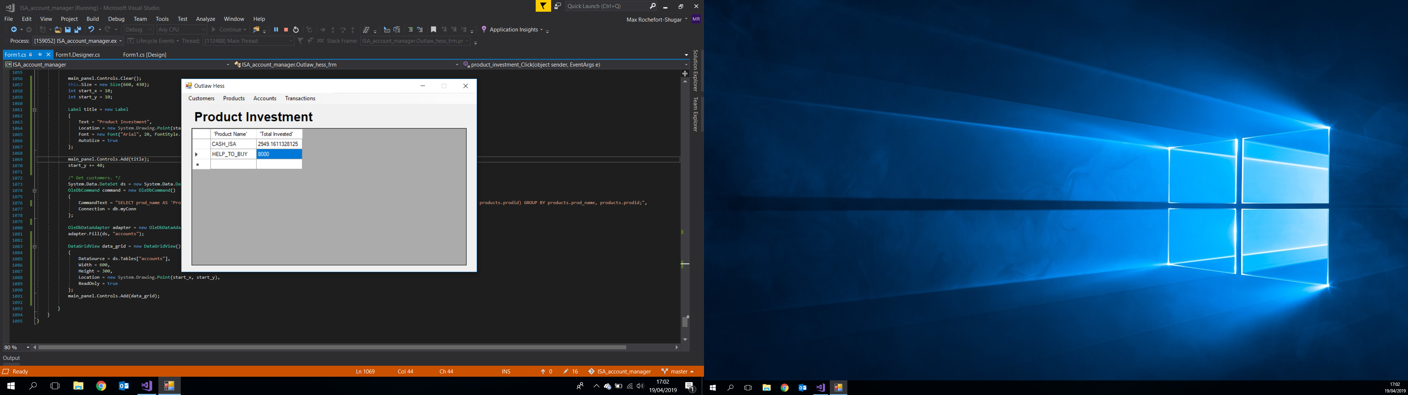

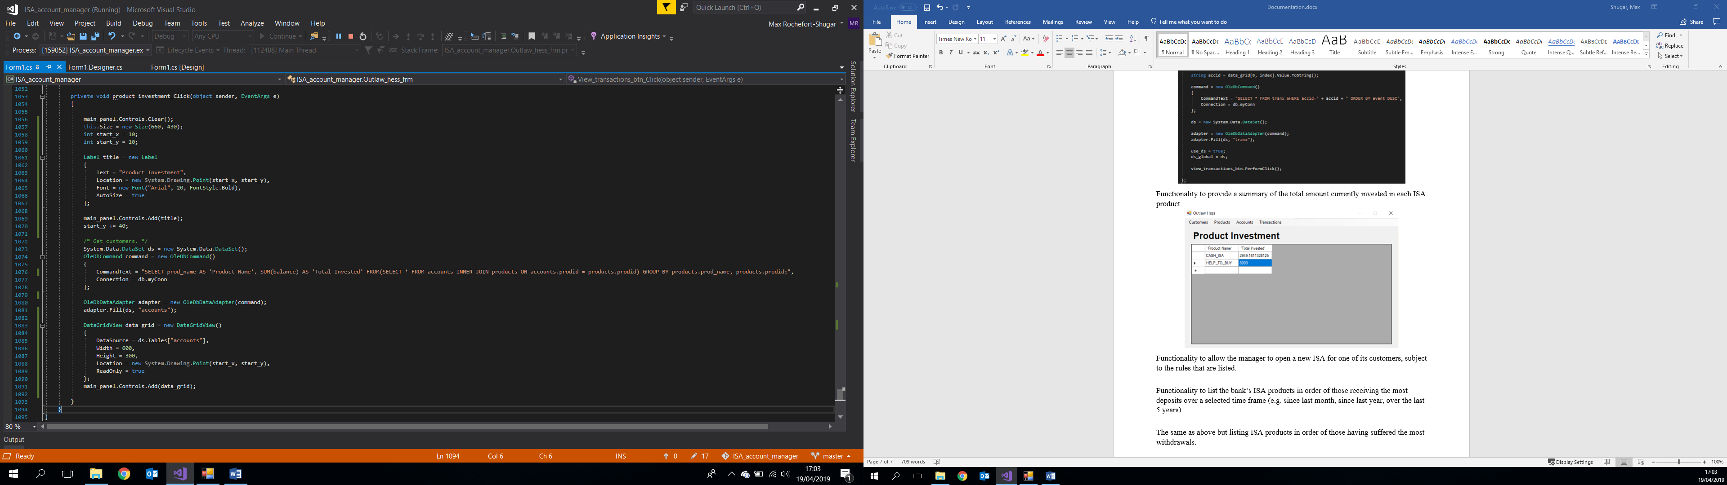

## 2.5 - Functionality to allow the manager to open a new ISA for one of its customers, subject to the rules that are listed.

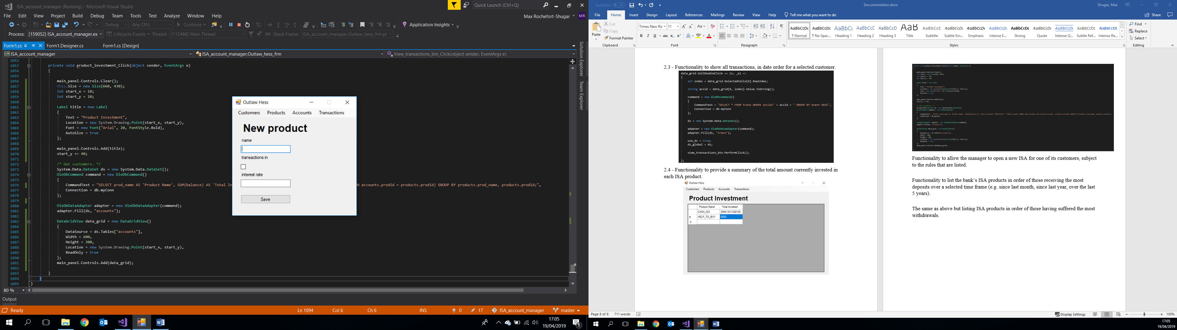

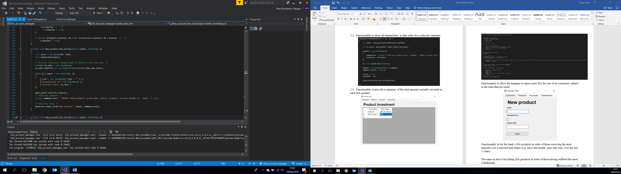

## 2.6 - Functionality to list the bank’s ISA products in order of those receiving the most deposits over a selected time frame (e.g. since last month, since last year, over the last 5 years).

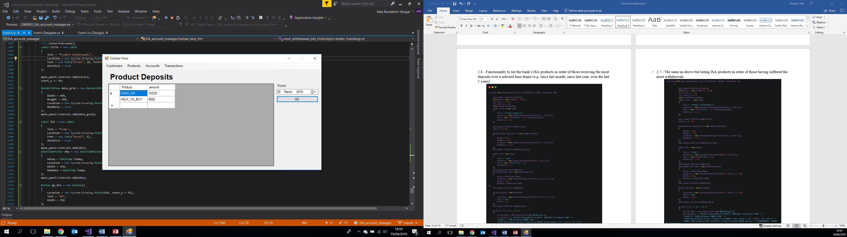

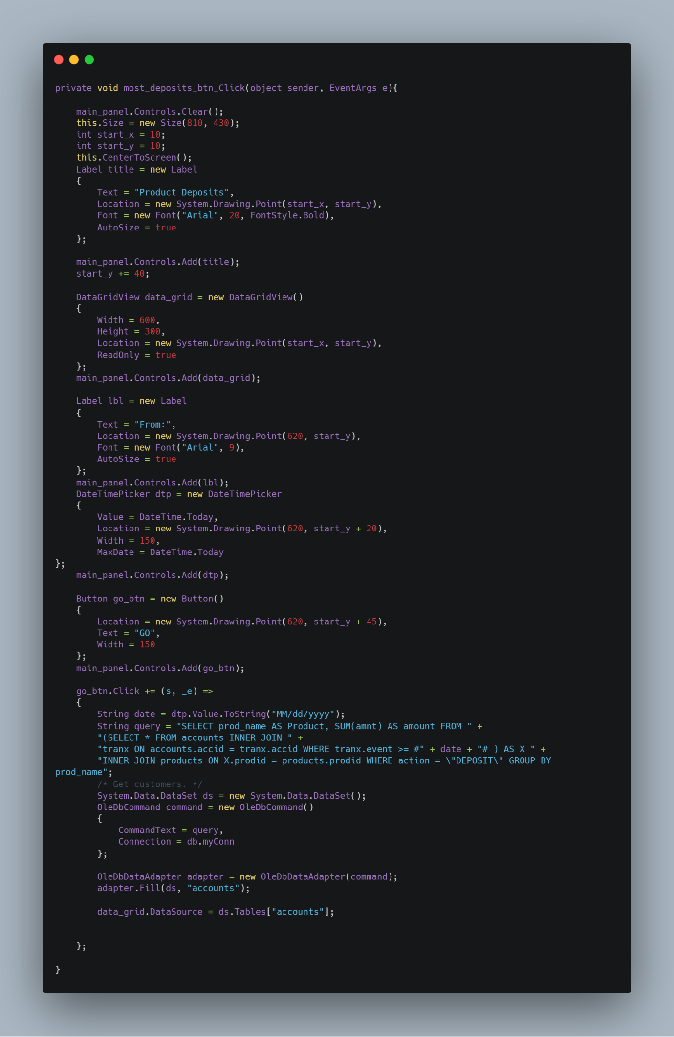

## 2.7 - The same as above but listing ISA products in order of those having suffered the most withdrawals.

